**ARCHITECTURE**

**UML sequence diagram**

* **Voting**

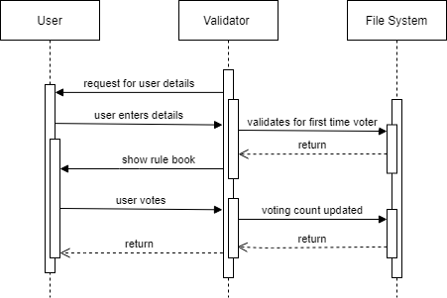

* **Add candidate**

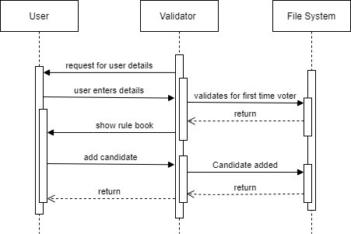

* **Live count**

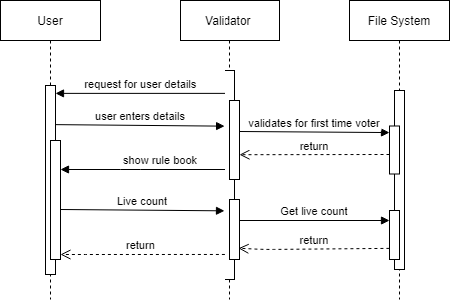

* **List of candidate**

